Name; Lagu Emmanuel Onama Legge VU -DIT-2411-0349-DAY

Link;  
QUESTION 1

Succesful calculation  
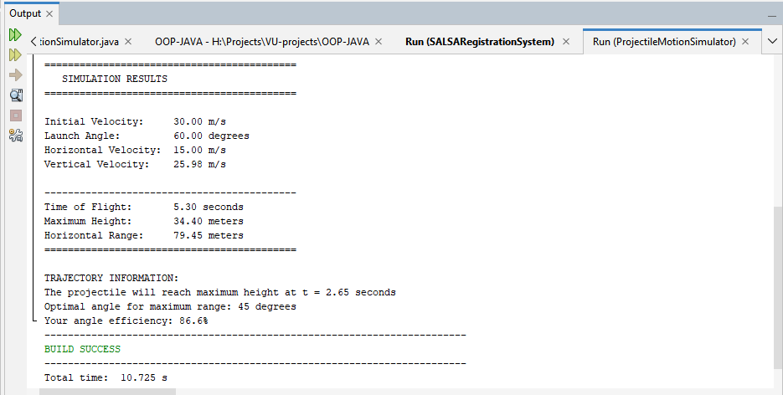

Validation Error  
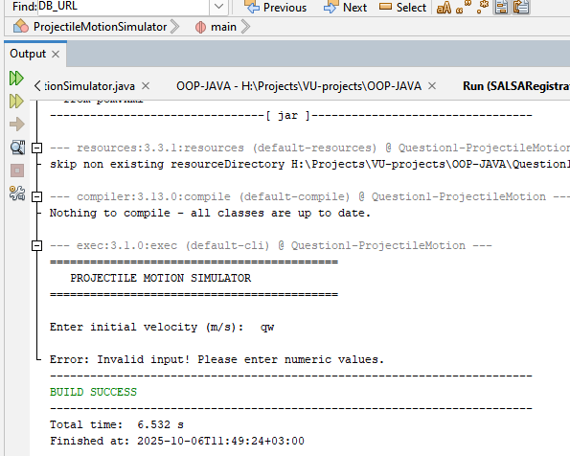

QUESTION 2

